# Eric Schmidt

## Intro

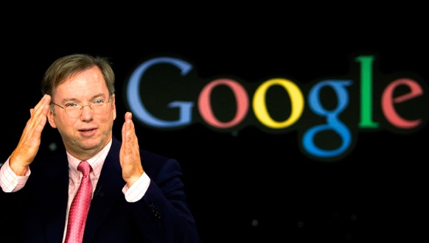Eric Schmidt is an American software engineer who served as chairman and CEO of Google Inc. overseeing a vast expansion of the companies activities. He is currently the

executive chairmen of Alphabet Inc. ,a

holding company which engages in the business of acquisition and operation of different companies.

## Early Life

Schmidt was born and raised in Virginia where his father was an international economics professor in Virginia Tech and his mother had a Master’s degree in psychology. He was a very good student in his school Yorktown High School where he did very well in his academics as well as being a successful long distance runner. He graduated from school in 1972. He joined Princeton University soon after as an architecture student however he lost interest in this and changed his major to electrical engineering before graduating with a Bachelor of Science degree in 1976. He then enrolled at the University of California, Berkeley where he earned a Master of Science degree after designing and implementing a network linking the campus computer centre with the Computer Science and Computer Engineering departments. He then also earned a PhD degree in Electrical Engineering and Computer Science. His dissertation was on the challenges of managing distributed software development.

## Career

### Bell Labs

Early in Schmidt’s career he worked at Bell Labs, a scientific research company where he worked in research and development. He would work alongside an American computer scientist named Mike Lesk to rewrite a program named Lex, a computer program used that generates lexical-analysers from regular expression descriptions for the Unix computer operating system.

### Sun Microsystems

In 1983 Sun Microsystems hired Schmidt as their first software manager. He was very successful in this role and two years later was promoted to be vice president of the company’s software products division. In 1988 he became vice president of the general systems group and then in 1992 Sun Microsystems reorganised and he was made president of one of the company’s offshoots, Sun Technology Enterprises. At Sun Schmidt was involved in developing the programming language ‘Java’.

### Novell

In April 1997, an American software and services company named Novell hired Schmidt to be CEO and chairman. At this period of time Novell were going through a tough time as Microsoft were shipping free TCP/IP stacks in Windows 95 making Novell much less profitable. Schmidt was therefore hired in order to revive the company and despite his best efforts he could not do so and so he left this job in 2001 after the acquisition of Cambridge Technology Partners.

### Google

Later in 2001, the founders of Google Larry Page and Sergey Brin interviewed Schmidt as Google was still a young company and they were looking for someone with experience to run the company. They were impressed by him and therefore recruited him as board chairman in March. By August, he had been appointed CEO of the company. It is said that he was mainly hired to oversee the founders who were still very young and unexperienced. He shared responsibility for Google’s day to day operations with both Page and Brin. He focused on building the corporate infrastructure needed to maintain Google’s growth and under his leadership the company was soon one of the fastest growing companies in the world. Under Schmidt’s leadership Google released many new products including Google News, Blogger, Google Books, Gmail, Google Earth and Google Maps, and acquired online video-sharing platform YouTube. In 2008, under Schmidt’s leadership Google put pressure on both rival companies Apple and Microsoft with the release of Android the operating system challenging Apple’s IOS and the Google Chrome web browser challenging Microsoft’s Internet Explorer. In 2011 Page replaced Schmidt as CEO of Google and Schmidt took the title of executive chairman where he was responsible for building partnerships and broader business relationships. He would now also act as an advisor to co-founders Page and Brin. In 2015 Google announced that it would rebrand itself as ‘Alphabet’, a new holding company whose largest wholly owned subsidiary was Google. Schmidt was named executive chairman the Alphabet board of directors, and he kept that position until 2018 when he became a technical advisor in the company as well. In February 2020, Schmidt ended his stint of nineteen years with the company when he left his post as technical advisor.

### The Impact of Eric Schmidt

In my opinion it is no over exaggeration to say that the work of Eric Schmidt has impacted the world hugely. He had an enormous impact on how Google existed and worked as a company from 2001 all the way to 2015. Google allows users to access information immediately by searching for anything and getting results in seconds, it allows us to access news in seconds reducing the need for printing and much more, all impacting the world massively.